**Hyper Spectral Image Processing Using Deep Learning Techniques**

**Rayasam Divija V.Mahesh Reddy E.VishnuVardhan**

Computer Science and Engineering Computer Science and Engineering Computer science and Engineering

Anurag University Anurag University Anurag University

Hyderabad, India Hyderabad, India Hyderabad,india

[divijarayasam06@gmail.com](mailto:divijarayasam06@gmail.com) [maheshreddy9420@gmail.com](mailto:maheshreddy9420@gmail.com) enugalavishnu2001@gmail.com

**Abstract:** Hyperspectral image processing is like a super tool that combines high-tech photography, smart computing, and nature-inspired problem-solving. It helps us gather, understand, and make sense of information from different kinds of light. This special tool is super important in areas like farming, keeping an eye on the environment, and even in defence. Recently, scientists have combined deep learning computer programs that can learn on their own with special problem-solving techniques inspired by nature. This powerful combination has made a huge difference in how we understand and use hyperspectral images. It's like giving us a super clear picture of materials and objects. This paper gives a clear picture of the main ideas, methods, and recent progress in hyperspectral image processing. It especially focuses on how these deep learning and evolutionary techniques work together. It also highlights how this mix can be super useful in lots of different fields. This reminds us that we should keep exploring and studying this exciting area because it has a lot of potential in many different areas of science and technology.

Keywords: Hyperspectral Image Processing, Remote Sensing, Spectral Information, Spatial Information, Classification.

**I. Introduction:**

A hyperspectral image (HSI) is a digital image that contains a broad range of electromagnetic wavelengths or spectral bands. Unlike regular images with only three bands RGB, HSIs have hundreds or even thousands of narrow and adjacent bands, covering a wide spectrum [1]. A HSI is created by dividing the electromagnetic spectrum into many narrow and adjacent bands, leading to a significant number of spectral channels. Each channel corresponds to a particular wavelength or a small range of wavelengths. Within a hyperspectral image, each pixel holds a distinctive spectral signature composed of intensity values that depict the object's reflectance or radiance at various wavelengths. This spectral data enables the identification and examination of the materials and characteristics of the objects captured in the image. A representation of HSI is shown in Fig. 1.

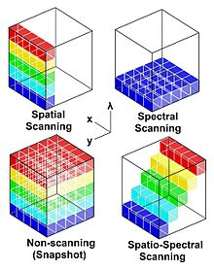

Figure 1: Representation of HSI

The HSI has many application areas which include remote sensing and earth observation [6], agriculture and crop monitoring [7], geology and mineralogy [8], forestry [9], urban planning and infrastructure [10], medical imaging and diagnostics [11], food quality and safety [12]. The main task in these applications is classification of pixels to identify the objects.

In the processing of HSIs, various classification methods were employed to classify the pixels or regions into distinct classes by leveraging their spectral characteristics. Some of the widely used

classification methods were k-nearest neighbours (KNN) [13], support vector machine (SVM) [14], random forest (RF) [14], maximum likelihood classifier (MLC) [15]and decision trees (DT) [16]. The performance of these methods was not satisfactory, because these methods struggle when the curse of dimensionality is high, limited training samples, spectral variability, correlated spectral bands and high computational complexity. Addressing these limitations often requires the development of specialized algorithms.

**II. Literature Review**

Last few years, deep learning (DL) methods demonstrated huge success across a wide array of applications, particularly in the field of hyperspectral image processing [1]. Among various DL methods, convolutional neural network (CNN) is very popular due to its powerful feature extraction technique. The CNN has the ability to extract both spectral and spatial information. In [2], introduces a CNN architecture that transforms 1D spectral vectors into 2D matrices to fully leverage the spectral information. For HSI classification, [3] presents a hybrid approach that employs convolutional layers to extract middle-level spectral features and recurrent layers to extract spectral contextual information. Likewise, [4] introduces a new CNN model for HSI classification that reduces overfitting by using smaller spatial patches. In [5], authors tackle the overfitting problem by using a combination of 2D-CNN and Gabor filtering. Moreover, spectral-spatial information integration is explored in HSI classification. In [6], proposes an efficient 3D-CNN framework that exploits both spectral and spatial information simultaneously. In [7], a two-stage hybrid deep framework jointly extracts spectral-spatial features using CNN and stacked AE. Similarly, [8] introduces a 3D-CNN model that effectively incorporates spectral and spatial features. [9] proposes a dual-channel CNN-based framework where 1D-CNN and 2D-CNN are utilized to extract spectral and spatial features, respectively. In [10], a combined metric learning-based framework with CNN is employed to fuse spectral and spatial features. [11] employs multiscale filtering in the CNN framework to enhance the HSI representational ability. [12] utilizes a three-channel virtual RGB image to extract spatial features and passes them to CNN for multi-scale feature extraction. In [13], a semi-supervised 3D-CNN is proposed, which incorporates an adaptive band selection strategy to exploit spectral-spatial features jointly. Similarly, spectral-spatial features are jointly extracted using a hybrid unsupervised 3D convolutional-autoencoder in [14]. In [15], employs a hybrid approach that combines a 3D-CNN for exploiting spectral-spatial features and a 2D-CNN model for obtaining abstract spatial features. From the above discussion, it has been observed that both spectral and spatial information are important for improving the HSI classification.

Other than spectral and spatial information, removing noisy bands is important criteria for improving the classification performance. Evolutionary algorithms (EAs) have a substantial impact on processing hyperspectral images for remote sensing, as they effectively tackle intricate issues linked with tasks like feature selection and classification. Paper [41] states that Particle Swarm Optimization’s cooperative particle interactions drive iterative fitness improvement, while its application to hyper-parameter selection has shown promise in achieving optimal solutions for tasks such as classification accuracy enhancement in hyperspectral imaging. In [40][23] the proposed Improved Ant Colony Algorithm (IMACA-BS) demonstrated superiority in selecting informative bands for classification of complex land cover classes. [38] introduces a band selection method based on Modified Hybrid Rice Optimization algorithm to enhance classification accuracy in hyperspectral images by removing correlated bands. EAs form a group of optimization and search algorithms that draw inspiration from the mechanisms of biological evolution and natural selection [18]. Their primary application lies in solving intricate optimization problems, particularly in scenarios where conventional gradient-based approaches may not be suitable or efficient. EAs replicate the mechanism of natural selection, favouring individuals possessing advantageous traits to survive and reproduce, thereby passing these traits to the succeeding generation [19]. Likewise, in EAs, potential solutions to a problem are considered individuals in a population, and their fitness is assessed based on their performance in the given task. Unlike traditional optimization techniques that work with a single solution, EAs maintain a population of candidate solutions. Through successive generations, these solutions evolve to achieve better fitness values. In recent times, evolutionary algorithms (EAs) have gained widespread use in feature selection due to their effective search capability in vast feature spaces [36]. These methods consist of genetic algorithm (GA), differential evolution (DE) algorithm, particle swarm optimization (PSO), gray wolf optimizer (GWO), cuckoo search (CS) algorithm, artificial bee colony (ABC) algorithm, and whale optimization algorithm (WOA). These algorithms are known for their potential to effectively handle feature selection tasks and offer superior performance [37]. Application of EAs on hyperspectral image (HSI) analysis has emerged as a highly engaging area in the realm of remote sensing, offering significant potential in comprehensively sensing vast environmental landscapes [38]. [39] employs the combination of genetic algorithm as an optimizer and support vector machines as a classifier for the identification of maximally-effective waveband combination of a hyperspectral image for early detection of disease symptoms in soybeans stems. Ant Colony Optimization algorithm has been used in the field of image processing, pattern recognition, and feature selection [40].

FCN, a variant of convolutional neural network (CNN), is specifically crafted for semantic segmentation duties. It substitutes the fully connected layers found in conventional CNNs with convolutional layers to retain spatial details. FCN is highly suitable for tasks involving per-pixel classification and segmentation, such as recognizing objects or notable areas in images. Its adaptation to hyperspectral image processing involves accommodating the numerous spectral bands in hyperspectral data and segmenting objects or land cover categories within these images. Initially developed for segmenting biomedical images, U-Net architecture has been embraced across diverse fields, including hyperspectral image examination. This design involves an encoder path (contracting) and a decoder path (expansive), forming a "U" shape. The encoder captures context, and the decoder reinstates spatial details, creating segmentation masks. U-Net proves valuable for tasks requiring meticulous segmentation with well-defined boundaries, like discerning land cover categories in hyperspectral images. The versatility of ResUNET's design allows it to be easily tailored to hyperspectral image processing tasks. It is capable of addressing the complexities introduced by the extensive spectral bands present in hyperspectral data and generating precise segmentation results for various categories of importance.

**III. Standard CNN Architecture:**

CNN are a specific kind of neural network with multiple layers, designed to identify visual patterns in pixel-based images [16]. In CNN, the term "convolution" refers to a mathematical operation that involves multiplying two functions to produce a third function, which describes how one function's shape can be modified by the other. In simpler terms, CNN uses matrix multiplication of two image representations to generate an output that extracts information from the image. CNN shares similarities with other neural networks, but its distinguishing feature is the inclusion of convolutional layers, which add a layer of complexity to the overall structure [17]. A convolutional neural network consists of multiple layers, including convolution layers, pooling layers, and fully connected layers. The details of each layer are given below:

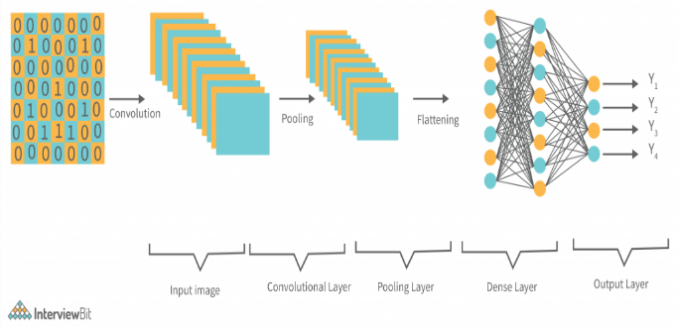

Fig 2: A typical architecture of CNN.

**Convolutional Layer:**

At the core of the CNN lies the convolutional layer. This pivotal layer applies convolutional filters, also known as kernels, to the input data in order to detect features such as edges, textures, and patterns. Each filter is relatively small in size compared to the input data and slides over the entire input using a specified stride. At each position, the filter performs element-wise multiplication with the corresponding input elements and sums the results to produce a feature map. The feature map can be represented as follow:

Where:

*l( i+m, j+n) is the value at position (i+m, j+n) in the input data.*

*K(m,n) is the value at position (m,n) in the convolutional filter.*

**Pooling Layer:**

Pooling layers play a critical role in reducing the spatial dimensions of the feature maps while preserving essential information. These layers aid in reducing computational complexity and controlling overfitting. A commonly used technique is max pooling, where the maximum value within a small region (pooling window) is retained, and the rest is discarded. This down sampling process retains the most salient features of the feature map.

**Fully Connected Layer:**

After several convolutional and pooling layers, the CNN model often includes one or more fully connected layers. These layers establish connections between every neuron from the preceding layer to every neuron in the current layer, forming a traditional neural network architecture. Fully connected layers assist in learning global relationships and making predictions based on the features learned by the previous layers.

**Output Layer:**

The output layer represents the final layer of the CNN model. In classification tasks, it typically consists of neurons equal to the number of classes to predict. The values of these neurons indicate the model's confidence in assigning the input data to each class.

In the process of training, these layers collaborate through forward propagation to learn the optimal set of weights and biases that optimize the model's performance on the given task. The learning process is facilitated through backpropagation and the optimization algorithm, which iteratively updates the model's parameters based on the gradients of the loss function with respect to the model's parameters.

**IV. Some notable CNN Architectures:**

**LeNet:**

LeNet, introduced in 1989 by Yann LeCun [42], stands out as one of the earliest deep neural network (DNN) models, characterized by its straightforward architecture. This model gained prominence for its capacity to execute computations more rapidly compared to its contemporaries. The LeNet architecture encompasses several layers, incorporating both convolutional and fully connected layers. These components play a pivotal role in extracting features from images. When applied to hyperspectral image processing, the LeNet framework can be adjusted to address the unique complexities of hyperspectral data. Hyperspectral imagery holds extensive spectral data, with each pixel encompassing information from numerous spectral bands. This abundant data can be effectively harnessed by modifying LeNet's structure to encompass the spectral dimension. The convolutional layers can be configured to accommodate the distinct spectral bands, enabling the capture of spectral features.

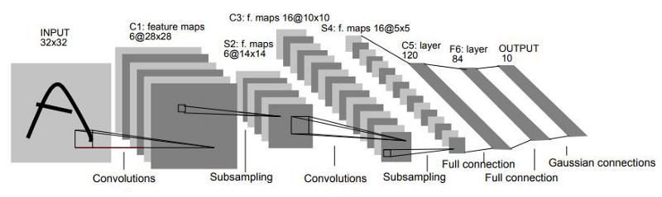

Fig: LeNet-5 Architecture

Furthermore, LeNet's convolutional layers' capacity for hierarchical feature learning is beneficial in identifying intricate spectral patterns that signify specific land cover categories. These acquired features can be employed in classification tasks, where the objective is to allocate each pixel to a particular land cover class. LeNet architecture, featuring its convolutional layers and feature extraction capabilities, can be customized for handling hyperspectral image data. Through adaptation and training on hyperspectral datasets, LeNet emerges as a valuable resource for tasks such as land cover classification, detection of spectral-based patterns, and various other applications within hyperspectral image analysis.

**AlexNet:**

**AlexNet** is a type of artificial neural network that is used for image recognition. It was first introduced in 2012 by Alex Krizhevsky, Ilya Sutskever, and Geoffrey Hinton. AlexNet won the ImageNet Large Scale Visual Recognition Challenge (ILSVRC) in 2012, and its architecture has been used as a starting point for many other CNNs. It is an innovative convolutional neural network (CNN) structure, which was initially crafted for the purpose of image classification within the realm of computer vision. Although its central emphasis was on RGB images, the concepts and attributes of AlexNet have stimulated modifications and usages across diverse fields, encompassing hyperspectral image analysis. AlexNet's convolutional layers are constructed to autonomously acquire layered features from input images, capturing varying abstraction levels, ranging from basic edges and textures to intricate patterns. In hyperspectral imagery, wherein each pixel encompasses numerous spectral bands, these convolutional layers can be harnessed to distill significant spectral and spatial attributes from the dataset. This proves especially advantageous for discerning nuanced patterns and distinguishing between land cover categories grounded in their spectral attributes.

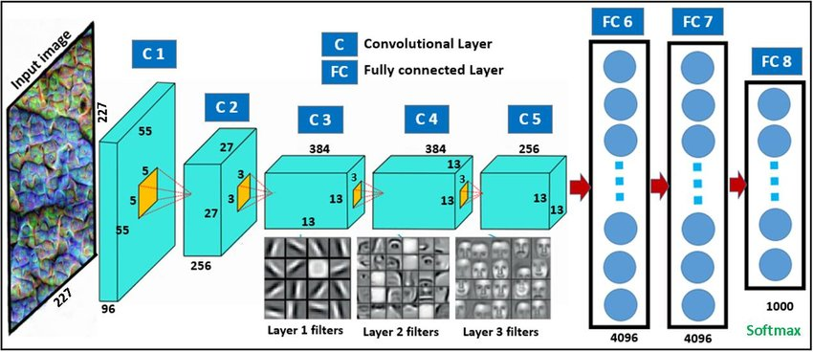

Fig 2: AlexNet Architecture

**Visual Geometry Group (VGG):**

VGG is a convolutional neural network (CNN) architecture that was developed by Karen Simonyan and Andrew Zisserman of the Visual Geometry Group at the University of Oxford. It is a simple and effective CNN architecture that is characterized by its use of small 3x3 convolutional filters and max pooling layers. VGG has been used as a starting point for many other CNN architectures, including ResNet, Inception, and DenseNet. VGG is still a popular CNN architecture and is used in a variety of tasks, including image classification, object detection, and semantic segmentation. It uses small 3x3 convolutional filters. This makes the network more computationally efficient and easier to train. It uses max pooling layers after each convolutional layer. This helps to reduce the size of the feature maps and to prevent overfitting. It has a large number of layers. This allows the network to learn more complex features from the images.

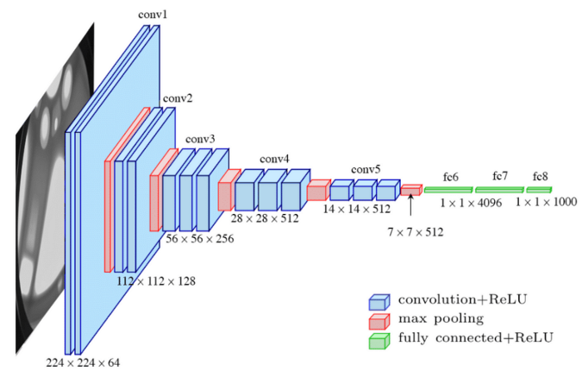

Fig 3: VGG 16 architecture

It is computationally expensive to train and deploy. It can be difficult to fine-tune for specific tasks. It is not as efficient as some newer CNN architectures.

**GoogLeNet:**

GoogLeNet, also known as Inception v1, is a convolutional neural network (CNN) architecture that was developed by researchers at Google in 2014. It won the ImageNet Large Scale Visual Recognition Challenge (ILSVRC) that year, and it has been used as a starting point for many other CNN architectures. It is characterized by its use of inception modules. Inception modules are a way of combining different sized convolutional filters in order to learn more complex features from the images. This makes GoogLeNet more efficient than previous CNN architectures, which typically used only one size of convolutional filter. It has 22 layers, including 9 inception modules. The first few layers of GoogLeNet are responsible for extracting low-level features from the images, such as edges and textures. The later layers of GoogLeNet are responsible for extracting high-level features, such as object parts and objects themselves.

GoogLeNet has been used to achieve state-of-the-art results on a variety of tasks, including image classification, object detection, and semantic segmentation. It is a powerful CNN architecture that is still widely used today. Uses inception modules to combine different sized convolutional filters. More efficient than previous CNN architectures. Can learn more complex features from images. Achieved state-of-the-art results on a variety of tasks.

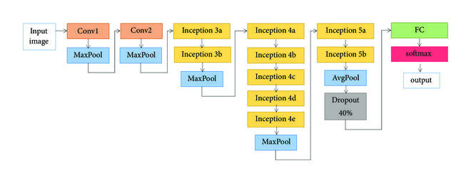Fig : GoogLeNet Architecture

GoogLeNet can be computationally expensive to train and deploy. It can be difficult to fine-tune for specific tasks. Not as efficient as some newer CNN architectures.

**ResNet:**

Residual Network, is a convolutional neural network (CNN) architecture that was introduced in 2015 by researchers at Microsoft Research. It won the ImageNet Large Scale Visual Recognition Challenge (ILSVRC) that year, and it has been used as a starting point for many other CNN architectures. ResNet is characterized by its use of residual connections. Residual connections are a way of adding the output of a layer to the input of the next layer. This helps to prevent the vanishing gradient problem, which is a problem that occurs when the gradients of the loss function become very small as the network becomes deeper. ResNet has a very deep architecture. The original ResNet architecture has 152 layers, but there are also smaller versions of ResNet with 50, 101, and 182 layers. The first few layers of ResNet are responsible for extracting low-level features from the images, such as edges and textures. The later layers of ResNet are responsible for extracting high-level features, such as object parts and objects themselves. ResNet has been used to achieve state-of-the-art results on a variety of tasks, including image classification, object detection, and semantic segmentation. It is a powerful CNN architecture that is still widely used today.

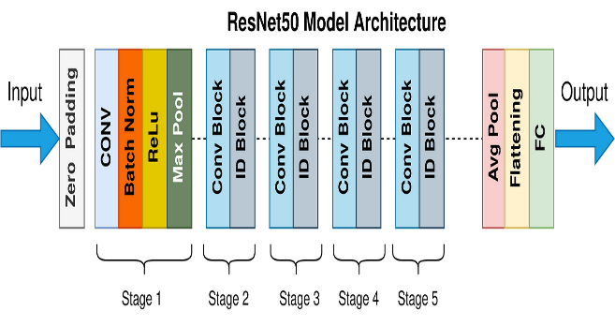

Fig: ResNet Architecture

**DenseNet:**

DenseNet, or Densely Connected Convolutional Network, is a convolutional neural network (CNN) architecture that was introduced in 2016 by researchers at the Hong Kong University of Science and Technology. It won the ImageNet Large Scale Visual Recognition Challenge (ILSVRC) that year, and it has been used as a starting point for many other CNN architectures. DenseNet is characterized by its use of dense connections.

Dense connections are a way of connecting all of the layers in the network directly to each other. This helps to improve the flow of information through the network and to prevent the vanishing gradient problem. DenseNet has a very compact architecture. The original DenseNet architecture has 121 layers, but there are also smaller versions of DenseNet with 169 and 201 layers. The first few layers of DenseNet are responsible for extracting low-level features from the images, such as edges and textures. The later layers of DenseNet are responsible for extracting high-level features, such as object parts and objects themselves. DenseNet has been used to achieve state-of-the-art results on a variety of tasks, including image classification, object detection, and semantic segmentation. It is a powerful CNN architecture that is still widely used today.

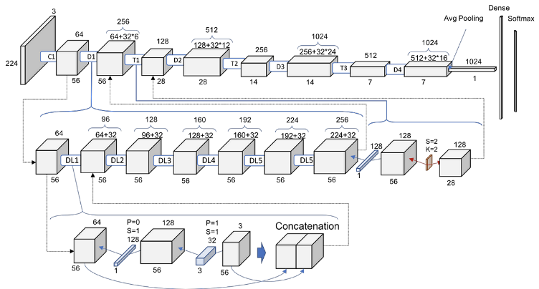

Fig: DenseNet Architecture

**UNet:**

UNet (short for Universal Network) is a convolutional neural network (CNN) architecture that is used for image segmentation. It was first introduced in the paper "U-Net: Convolutional Networks for Biomedical Image Segmentation" by Olaf Ronneberger, Philipp Fischer, and Thomas Brox in 2015. UNet is a fully convolutional network, which means that it has no fully connected layers. This makes it more efficient for image segmentation tasks, as fully connected layers are not able to handle the spatial information of images. UNet has a U-shaped architecture, which consists of a contracting path and an expanding path. The contracting path is responsible for extracting features from the input image, while the expanding path is responsible for up sampling the features and generating the output segmentation map. The contracting path consists of a series of convolutional layers and max pooling layers. The convolutional layers extract features from the input image, while the max pooling layers reduce the size of the feature maps. The expanding path consists of a series of convolutional layers and up sampling layers. The convolutional layers up sample the features, while the up-sampling layers increase the size of the feature maps. The features extracted from the contracting path are concatenated with the up sampled features from the expanding path. This allows UNet to learn both local and global features of the input image. UNet has been used to achieve state-of-the-art results on a variety of image segmentation tasks, including biomedical image segmentation, semantic segmentation, and instance segmentation. It is a powerful and versatile CNN architecture that is still widely used today.

**V. Evolutionary Algorithms:**

In EAs, candidate solutions are commonly expressed as strings of data, referred to as chromosomes or genomes. The genetic representation can be customized to suit the particular problem domain, offering adaptability in managing different types of variables. EAs utilize a selection mechanism to pick individuals from the population based on their fitness. Individuals with superior performance have a greater probability of being chosen, emulating the concept of "survival of the fittest" in natural selection. Crossover is a genetic operator that involves merging two parent solutions to produce new offspring. This process fosters exploration and facilitates the exchange of advantageous traits between solutions, potentially leading to improved solutions. Mutation introduces random alterations to the candidate solutions, preserving diversity in the population and safeguarding against premature convergence to suboptimal solutions as shown in figure 2. EAs keep evolving the population until a specified termination condition is satisfied, which could be reaching a maximum number of generations or attaining a desired level of solution quality.

Two common methods for dimension reduction in hyperspectral datasets are feature extraction and feature selection. Feature extraction techniques like independent component analysis (ICA) [20], principal component analysis (PCA) [21], and local linear embedding (LLE) transform [22] the original data into a lower-dimensional and less redundant feature space. However, they might lose some physical information during the compression process [23]. On the other hand, feature selection retains the most informative features while preserving the physical meaning of the original data, making it a popular method for dimension reduction [24]. In traditional filter methods, the feature subset is selected independently of the classifier or classification algorithm and evaluated using measures like distance, correlation, and information[24]. Wrapper methods, on the other hand, employ the classifier model to estimate feature subsets, resulting in more accurate selections [25]. Although filter methods are computationally efficient, they tend to be less accurate than wrapper methods since they lack classifier guidance [26]. Feature-selection methods can be classified as supervised and unsupervised based on the availability of sample tags [27]. Unsupervised methods can select bands without class labels but may be unstable and biased due to the absence of prior information [28]. Conversely, supervised methods yield better feature-selection results by utilizing class labels for assistance.

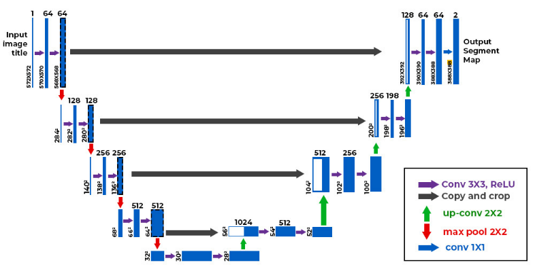

Fig: U-Net Architecture

**IV. Summery :**

|  |  |  |
| --- | --- | --- |
| **CNN Architecture** | **Dataset Focus** | **Remote Sensing Applications** |
| AlexNet | ImageNet | Land cover classification with hyperspectral data |
| VGGNet | ImageNet | Land use classification, feature extraction |
| GoogLeNet (Inception) | ImageNet | Land cover classification, multi scale feature extraction |
| ResNet | ImageNet | Object detection, feature extraction |
| DenseNet | ImageNet | Land cover classification, feature reuse |
| MobileNet | It is not dataset specific | Real time object detection, classification with resource constraints |
| UNet | Biomedical Image Segmentation | Road Extraction, building segmentation |
| Fully Convolutional Networks (FCN) | Semantic Segmentation | Land cover classification, detailed image labelling. |
| SegNet | Road Scene understanding | Semantic Segmentation in aerial and satellite imagery |
| DeepLab | Semantic Segmentation | Land cover mapping, precise segmentation in high-resolution energy. |

Table 1: Summery of various CNN architectures, their dataset focuses and their application in remote sensing.

|  |  |  |
| --- | --- | --- |
| **Evolutionary Algorithm** | **Datasets** | **Applications** |
| Genetic Algorithms (GA) | Hyperspectral, Multispectral | * Feature Selection for classification. * Optimization of remote sensing parameters. * Land cover classification * Change Detection |
| Differential Evolution (DE) | Multispectral, Hyperspectral | * Feature Selection for classification. * Spectral Unmixing. * Land use classification. |
| Particle Swarm Optimization (PSO) | Satellite, Aerial Imagery | * Feature Selection for classification. * Object Detection. * Sensor Network Optimization. |
| Artificial Bee Colony (ABC) | Multispectral, Hyperspectral | * Feature Selection for classification. * Optimization for Image segmentation and clustering. |
| Cuckoo Search (CS) | Hyperspectral, SAR | * Feature Selection for classification. * Image registration for remote sensing tasks. |
| Evolutionary Strategies (ES) | Multispectral, Hyperspectral | * Parameter optimization for remote sensing algorithms. |
| Genetic Programming (GP) | Hyperspectral | * Feature Generation for improved classification and analysis. |

Table 2: Summery of evolutionary algorithms used in remote sensing

**V. Results Comparison:**

In the domain of hyperspectral image (HSI) band selection, various algorithms have been explored by different researchers. Nagasubramanian et al.[29] utilized Genetic Algorithm (GA) to identify the optimal subset of bands and Support Vector Machine (SVM) for classifying infected and healthy samples. They replaced the classification accuracy with F1-Score to address the issue of unbalanced datasets, and their results demonstrated that the selected bands provided more informative data compared to RGB images. Xie et al. [30] introduced a band selection method based on the Artificial Bee Colony (ABC) algorithm and enhanced subspace decomposition for HSI classification. They computed the relevance between adjacent bands to achieve subspace decomposition, and then guided the ABC algorithm with enhanced subspace decomposition and maximum entropy to optimize the combination of selected bands. Their approach outperformed six related techniques, achieving high classification accuracy. Wang et al. [31] proposed a wrapper feature-selection approach that combined an improved version of the Ant Lion Optimizer (ALO) with wavelet SVM to reduce the dimension of HSI. They employed Lévy flight to assist ALO in escaping local optima, and wavelet SVM enhanced the stability of classification results. Their method demonstrated satisfactory classification accuracy using fewer frequency bands. In subsequent work, Wang et al. [32] designed a new band selection method that utilized chaos operation to set corresponding indices for the top three gray wolves in Grey Wolf Optimizer (GWO), thereby improving the optimization ability of GWO. Experimental results showed that this approach yielded a suitable band subset and achieved superior classification accuracy. Kavitha and Jenifa [33] employed Discrete Wavelet transform with eight taps and four taps for feature extraction and used Particle Swarm Optimization (PSO) to search for the optimal band subsets. They then applied SVM as a classifier for effective HSI classification. Medjahed et al. [34] introduced a novel band selection framework based on the binary Cuckoo Search (CS) algorithm. They compared the optimization ability of CS under two different objective functions and demonstrated that it outperformed relevant approaches by utilizing a few instances for training. Su et al. [35] proposed a modified version of the Firefly Algorithm (FA) to tackle the band selection problem by optimizing the minimum values of the objective function. Their method achieved superior results compared to Sequential Forward Selection (SFS) and PSO. Despite the progress made with these algorithms, band selection remains a challenging NP-hard problem. As the number of bands increases, the above algorithms might face premature convergence and optimization stagnation.

Some of the false colour and ground truth hyperspectral images are shown below:

Botswana images, built over Okavango Delta, Botswana on May 31.

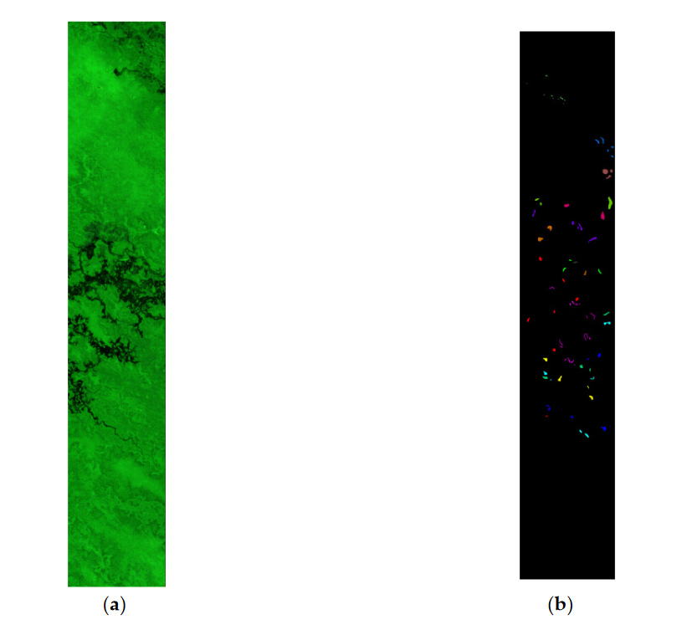

Fig 3. (a) Botswana HIS. (b) Ground Truth

The Indian pines dataset was gathered by AVIRIS sensor in northwestern Indiana.

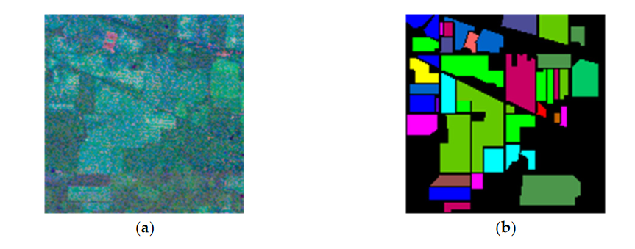

Fig 4. (a) Indian Pines. (b) Ground Truth

The Salinas dataset was obtained by an AVIRIS sensor on Salinas valley.

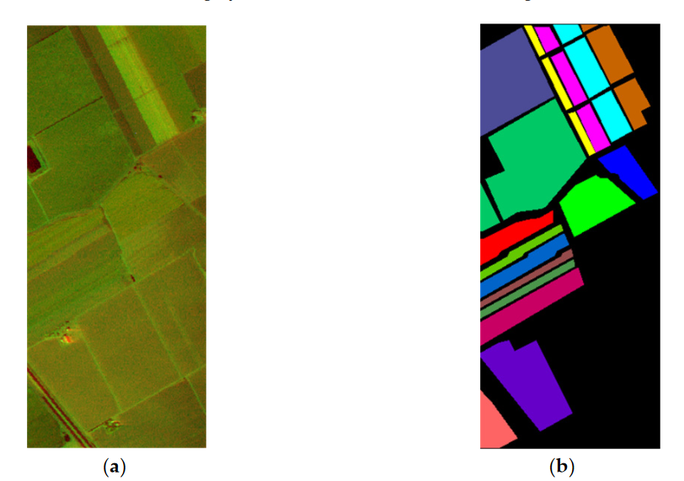

Fig 5. (a) Salinas HIS. (b) Ground Truth

Pavia university dataset is a 610x340 pixels image, collected from Pavia University in 2002.

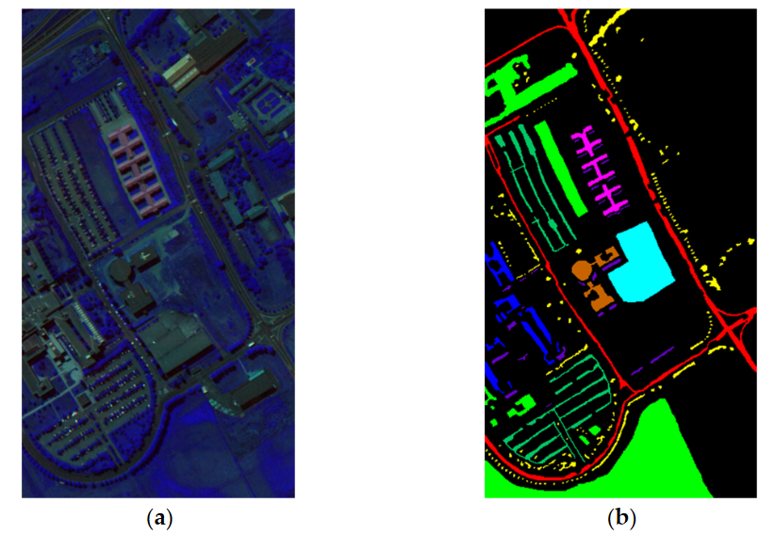

Fig 6. (a) Pavia University. (b) Ground Truth

**Table 4: Parameters of standard evolutionary algorithms and their values.**

|  |  |  |
| --- | --- | --- |
| **Algorithm** | **Parameters** | **Value** |
| GA | Crossover Rate CR  Mutation Rate CM | 0.8  0.01 |
| PSO | Acceleration coefficients c1, c2.  Minimum inertia weight wmin  Maximum inertia weight wmax | 2  0.2  0.9 |
| CS | Detection Probability pa | 0.25  1.25 |
| FA | Absorption coefficient  Initial attraction 0  Randomization Parameter | 1  1  0.5 |

**Conclusion:**

In conclusion, the integration of deep learning methods with evolutionary algorithms in hyperspectral image processing marks a significant leap forward in our ability to extract meaningful insights from complex data. This powerful combination enhances our capacity for precise material characterization and classification, with applications spanning agriculture, environmental monitoring, and defense. The dynamic and evolving nature of this field underscores the need for ongoing research and exploration. As we continue to unlock the full potential of hyperspectral imaging, we open new doors to understanding and leveraging the rich spectrum of electromagnetic frequencies for a multitude of scientific and technological advancements.

References:

[1] A. Shabna, and R. Ganesan, “HSEG and PCA for Hyper-spectral Image Classification,” IEEE International Conference on Control, Instrumentation, Communication and Computational Technologies (ICCICCT), 2014.

[2] Gao, H., Yang, Y., Li, C., Zhou, H. and Qu, X., 2018. Joint alternate small convolution and feature reuse for hyperspectral image classification. ISPRS International Journal of Geo-Information, 7(9), p.349.

[3] Wu, H. and Prasad, S., 2017. Convolutional recurrent neural networks forhyperspectral data classification. Remote Sensing, 9(3), p.298.

[4] Haut, J.M., Paoletti, M.E., Plaza, J., Plaza, A. and Li, J., 2019. Hyperspectral image classification using random occlusion data augmentation. IEEE Geoscience and Remote Sensing Letters, 16(11), pp.1751-1755.

[5] Chen, Y., Zhu, L., Ghamisi, P., Jia, X., Li, G. and Tang, L., 2017. Hyperspectral images classification with Gabor filtering and convolutional neural network. IEEE Geoscience and Remote Sensing Letters, 14(12), pp.2355-2359.

[6] Paoletti, M.E., Haut, J.M., Plaza, J. and Plaza, A., 2018. A new deep convolutional neural network for fast hyperspectral image classification. ISPRS journal of photogrammetry and remote sensing, 145, pp.120-147.

[7] Li, S., Zhu, X., Liu, Y. and Bao, J., 2019. Adaptive spatial-spectral feature learning for hyperspectral image classification. IEEE Access, 7, pp.61534-61547.

[8] Li, Y., Zhang, H. and Shen, Q., 2017. Spectral–spatial classification of hyperspectral imagery with 3D convolutional neural network. Remote Sensing, 9(1), p.67.

[9] Zhang, H., Li, Y., Zhang, Y. and Shen, Q., 2017. Spectral-spatial classification of hyperspectral imagery using a dualchannel convolutional neural network. Remote sensing letters, 8(5), pp.438-447.

[10] Cheng, G., Li, Z., Han, J., Yao, X. and Guo, L., 2018. Exploring hierarchical convolutional features for hyperspectral image classification. IEEE Transactions on Geoscience and Remote Sensing, 56(11), pp.6712-6722.

[11] Zhong, P., Peng, N. and Wang, R., 2015. Learning to diversify patch-based priors for remote sensing image restoration. IEEE Journal of Selected Topics in Applied Earth Observations and Remote Sensing, 8(11), pp.5225-5245.

[12] Liu, L., Shi, Z., Pan, B., Zhang, N., Luo, H. and Lan, X., 2020. Multiscale deep spatial feature extraction using virtual RGB image for hyperspectral imagery classification. Remote Sensing, 12(2), p.280.

[13] Sellami, A., Farah, M., Farah, I.R. and Solaiman, B., 2019. Hyperspectral imagery classification based on semisupervised 3-D deep neural network and adaptive band selection. Expert Systems with Applications, 129, pp.246-259.

[14] Mei, S., Ji, J., Geng, Y., Zhang, Z., Li, X. and Du, Q., 2019. Unsupervised spatial–spectral feature learning by 3D convolutional autoencoder for hyperspectral classification. IEEE Transactions on Geoscience and Remote Sensing, 57(9), pp.6808-6820

[15] Chen, C., Li, Y., & Liao, W. (2016). Deep feature extraction and classification of hyperspectral images based on convolutional neural networks. IEEE Transactions on Geoscience and Remote Sensing, 54(10), 6232-6251.

[16] Ma, L., Cheng, G., Li, J., & Zhao, D. (2016). Hyperspectral image classification using deep pixel-pair features. IEEE Transactions on Geoscience and Remote Sensing, 54(8), 4808-4822.

[17] Luo, H., Zhang, Y., Tao, D., & Huang, H. (2018). Hyperspectral image classification with deep learning models. IEEE Transactions on Geoscience and Remote Sensing, 56(9), 5408-5423.

[18] B. Xue, M. Zhang, W. N. Browne and X. Yao, "A Survey on Evolutionary Computation Approaches to Feature Selection," in IEEE Transactions on Evolutionary Computation, vol. 20, no. 4, pp. 606-626, Aug. 2016, doi: 10.1109/TEVC.2015.2504420.

[19] J. Zhang et al., "Evolutionary Computation Meets Machine Learning: A Survey," in IEEE Computational Intelligence Magazine, vol. 6, no. 4, pp. 68-75, Nov. 2011, doi: 10.1109/MCI.2011.942584.

[20] Li, R.; Zhang, H.; Chen, Z.; Yu, N.; Kong, W.; Li, T.; Wang, E.; Wu, X.; Liu, Y. Denoising method of ground-penetrating radar signal based on independent component analysis with multifractal spectrum. *Measurement* **2022**, *192*, 110886.

[21] Xie, S. Feature extraction of auto insurance size of loss data using functional principal component analysis. *Expert Syst. Appl.* **2022**, *198*, 116780.

[22] Liu, Q.; He, H.; Liu, Y.; Qu, X. Local linear embedding algorithm of mutual neighborhood based on multi-information fusion metric. *Measurement* **2021**, *186*, 110239.

[23] Ding, X.; Li, H.; Yang, J.; Dale, P.; Chen, X.; Jiang, C.; Zhang, S. An improved ant colony algorithm for optimized band selection of hyperspectral remotely sensed imagery. *IEEE Access* **2020**, *8*, 25789–25799.

[24] Zhang, A.; Ma, P.; Liu, S.; Sun, G.; Huang, H.; Zabalza, J.; Wang, Z.; Lin, C. Hyperspectral band selection using crossover-based gravitational search algorithm. *IET Image Processing* **2019**, *13*, 280–286.

[25] Wah, Y.B.; Ibrahim, N.; Hamid, H.A.; Abdul-Rahman, S.; Fong, S. Feature Selection Methods: Case of Filter and Wrapper Approaches for Maximising Classification Accuracy. *Pertanika J. Sci. Technol.* **2018**, *26*, 329–340.

[26] Ghosh, M.; Guha, R.; Sarkar, R.; Abraham, A. A wrapper-filter feature selection technique based on ant colony optimization. *Neural Comput. Appl.* **2020**, *32*, 7839–7857.

[27] Wang, J.; Tang, C.; Li, Z.; Liu, X.; Zhang, W.; Zhu, E.; Wang, L. Hyperspectral band selection via region-aware latent features fusion based clustering. *Inf. Fusion* **2022**, *79*, 162–173.

[28] Shi, J.; Zhang, X.; Liu, X.; Lei, Y.; Jeon, G. Multicriteria semi-supervised hyperspectral band selection based on evolutionary multitask optimization. *Knowl. -Based Syst.* **2022**, *240*, 107934.

[29] Nagasubramanian, K.; Jones, S.; Sarkar, S.; Singh, A.K.; Singh, A.; Ganapathysubramanian, B. Hyperspectral band selection using genetic algorithm and support vector machines for early identification of charcoal rot disease in soybean stems. *Plant Methods* **2018**, *14*, 86.

[30] Xie, F.; Li, F.; Lei, C.; Yang, J.; Zhang, Y. Unsupervised band selection based on artificial bee colony algorithm for hyperspectral image classification. *Appl. Soft Comput.* **2019**, *75*, 428–440.

[31] Wang, M.; Wu, C.; Wang, L.; Xiang, D.; Huang, X. A feature selection approach for hyperspectral image based on modified ant lion optimizer. *Knowl. -Based Syst.* **2019**, *168*, 39–48.

[32] Wang, M.; Liu, W.; Chen, M.; Huang, X.; Han, W. A band selection approach based on a modified gray wolf optimizer and weight updating of bands for hyperspectral image. *Appl. Soft Comput.* **2021**, *112*, 107805.

[33] Kavitha, K.; Jenifa, W. Feature Selection Method for Classifying Hyper Spectral Image Based on Particle Swarm Optimization. In Proceedings of the 2018 International Conference on Communication and Signal Processing (ICCSP), Chennai, India, 3–5 April 2018; pp. 119–123.

[34] Medjahed, S.A.; Saadi, T.A.; Benyettou, A.; Ouali, M. Binary cuckoo search algorithm for band selection in hyperspectral image classification. *IAENG Int. J. Comput. Sci.* **2015**, *42*, 183–191.

[35] Su, H.; Yong, B.; Du, Q. Hyperspectral band selection using improved firefly algorithm. *IEEE Geosci. Remote Sens. Lett.* **2015**, *13*, 68–72.

[36] Turky, A.; Sabar, N.R.; Dunstall, S.; Song, A. Hyper-heuristic local search for combinatorial optimisation problems. Knowl. -Based Syst. 2020, 205, 106264.

[37] P. R. Sekhar and B. Sujatha, "A Literature Review on Feature Selection using Evolutionary Algorithms," 2020 7th International Conference on Smart Structures and Systems (ICSSS), Chennai, India, 2020, pp. 1-8, doi: 10.1109/ICSSS49621.2020.9202257.

[38] Ye Z, Cai W, Liu S, Liu K, Wang M, Zhou W. A Band Selection Approach for Hyperspectral Image Based on a Modified Hybrid Rice Optimization Algorithm. Symmetry. 2022; 14(7):1293. <https://doi.org/10.3390/sym14071293>.

[39] Nagasubramanian, K.; Jones, S.; Sarkar, S.; Singh, A.K.; Singh, A.; Ganapathysubramanian, B. Hyperspectral band selection using genetic algorithm and support vector machines for early identification of charcoal rot disease in soybean stems. *Plant Methods* **2018**, *14*, 86.

[40] X. Ding et al., "An Improved Ant Colony Algorithm for Optimized Band Selection of Hyperspectral Remotely Sensed Imagery," in IEEE Access, vol. 8, pp. 25789-25799, 2020, doi: 10.1109/ACCESS.2020.2971327.

[41] Pablo Ribalta Lorenzo, Jakub Nalepa, Luciano Sanchez Ramos, and José Ranilla Pastor. 2017. Hyper-parameter selection in deep neural networks using parallel particle swarm optimization. In Proceedings of the Genetic and Evolutionary Computation Conference Companion (GECCO '17). Association for Computing Machinery, New York, NY, USA, 1864–1871. <https://doi.org/10.1145/3067695.3084211>

[42] Y. Lecun, L. Bottou, Y. Bengio and P. Haffner, "Gradient-based learning applied to document recognition," in Proceedings of the IEEE, vol. 86, no. 11, pp. 2278-2324, Nov. 1998, doi: 10.1109/5.726791.